**Chatbot for Mental Health Support**

## A PHASE REPORT 1

***Submitted by***

# Avinash Kumar(20BCS1108)

# Rishabh Sharma (20BCS1068)

# Abdullah Al Kawsar (20BCS1240)

# Nishant Rattan(20BCS5772)

**Sunny (20BCS1016)**

***in partial fulfillment for the award of the degree of***

# BACHELOR OF ENGINEERING

**IN**

COMPUTER SCIENCE AND ENGINEERING



**Chandigarh University**

SEPTEMBER 2023

# ABSTRACT

The advancement of technology has opened new avenues for providing mental health support and intervention. This project report presents the design, development, and implementation of a Chatbot for Mental Health Support (CMHS) aimed at addressing the growing demand for accessible and immediate mental health resources. The CMHS leverages natural language processing (NLP) techniques and a user-centric approach to deliver empathetic and personalized support to individuals facing mental health challenges.

The project begins with an extensive literature review on the current state of mental health support systems, highlighting the gaps and limitations in existing solutions. Subsequently, we outline the methodology employed in the development of the CMHS, which includes data collection, pre-processing, and the training of the NLP model. Ethical considerations, privacy, and data security protocols are also discussed in depth.

The CMHS is designed to be accessible through multiple platforms, including web and mobile applications, making it available to a wide range of users. Its features include mood tracking, emotional well-being assessments, crisis intervention, and a knowledge base of evidence-based mental health resources and strategies. The chatbot is capable of engaging users in natural and supportive conversations, providing coping strategies, and offering immediate assistance in crisis situations.

Throughout the project, user-centered design principles are employed to ensure the CMHS's effectiveness and user-friendliness. User feedback and iterative improvements are integral to the development process.

The evaluation of the CMHS is conducted through user surveys, interviews, and usage analytics. Preliminary results indicate high user satisfaction and perceived effectiveness in providing mental health support. The report also discusses the challenges faced during the project, including the need for ongoing maintenance and the importance of maintaining user trust.

In conclusion, this project report presents the successful development and implementation of a Chatbot for Mental Health Support, demonstrating its potential to bridge the gap in mental health care accessibility. The CMHS serves as a valuable tool for individuals seeking immediate support and resources for their mental health concerns, with the potential to alleviate some of the burden on traditional mental health care services. Future work will focus on further refining the chatbot's capabilities, expanding its user base, and ensuring its ongoing effectiveness in promoting mental well-being.

# INTRODUCTION

## Client Identification/Need Identification/Identification of relevant Contemporary issues

**Client Identification:**

Identifying the primary client or stakeholders is the first step in this project. This may include:

Mental Health Organizations: Organizations dedicated to promoting mental well-being and providing resources to those in need could be potential clients. They often have a keen interest in innovative solutions to reach a broader audience.

**Healthcare Providers**: Hospitals, clinics, or individual practitioners may seek technology-driven tools to complement their services and offer extended support to their patients.

**Educational Institutions**: Schools, colleges, and universities often have a vested interest in addressing mental health issues among students and could be potential clients or collaborators.

**Corporate Entities**: Companies and employers recognize the importance of employee mental health and may seek tools to support their staff.

**Government Agencies**: Public health departments or governmental bodies working on mental health initiatives may also be interested in such projects to enhance the overall mental well-being of their constituents.

**Need Identification:**

Understanding the needs and challenges related to mental health is essential. Key considerations include:

**Mental Health Awareness**: Identify the level of awareness and stigma associated with mental health issues in the target population.

**Access to Mental Health Services**: Determine the availability and accessibility of mental health services in the community. Identify any gaps or limitations.

**User Demographics**: Analyze the demographics of potential users, including age, gender, and cultural background, as these factors can influence their mental health needs and preferences.

**Contemporary Issues**: Recognize the specific contemporary issues affecting mental health, such as the impact of the COVID-19 pandemic, social isolation, economic stressors, and other relevant factors.

**Technological Literacy**: Assess the level of technological literacy among the target population to ensure that the chatbot solution is user-friendly and accessible.

**Privacy and Ethical Concerns**: Identify privacy and ethical concerns related to mental health data, ensuring that the project complies with legal and ethical standards.

**Identification of Relevant Contemporary Issues:**

Understanding and addressing contemporary issues related to mental health is critical in the development of a chatbot for mental health support. These issues may include:

**Pandemic-Related Mental Health Challenges**: Analyze the impact of the COVID-19 pandemic on mental health, including increased anxiety, depression, and social isolation.

**Social Media and Cyberbullying**: Consider the role of social media platforms and online interactions in shaping mental health, including cyberbullying and the spread of misinformation.

**Mental Health Disparities**: Examine disparities in mental health care access and outcomes, particularly among marginalized communities.

**Workplace Stress**: Explore the mental health challenges associated with remote work, job insecurity, and work-related stressors.

**Youth Mental Health**: Recognize the unique challenges faced by children and adolescents in today's digital age, including excessive screen time and online harassment.

**Mental Health Advocacy and Support**: Identify the role of advocacy groups, nonprofits, and support networks in addressing contemporary mental health issues.

By comprehensively identifying clients, needs, and contemporary issues, project teams can develop a chatbot for mental health support that is not only technically proficient but also responsive to the evolving landscape of mental health challenges.

## 1.2 . Identification of Problem

### Problem Statement:

The problem at hand is the significant and growing gap in accessible and immediate mental health support for individuals facing emotional distress and mental health challenges. This gap is exacerbated by a variety of factors, including stigma, resource limitations, and the reluctance of many individuals to seek traditional mental health care.

**Key Aspects of the Problem:**

**Limited Accessibility**: A considerable portion of the population faces obstacles in accessing mental health support services due to factors like geographical distance, high costs, and long waiting lists for appointments.

**Stigmatization of Mental Health**: The pervasive stigma surrounding mental health issues discourages individuals from openly discussing their struggles and seeking professional assistance, contributing to delayed or inadequate care.

**Delayed Intervention**: Many individuals do not receive timely intervention for their mental health concerns, leading to the escalation of these issues into more severe conditions.

**Resource Shortages**: Shortages of mental health professionals and insufficient funding for mental health programs result in inadequate support and prolonged wait times for those in need.

**Isolation and Loneliness**: The modern, often digitally connected, yet physically isolated lifestyle has heightened feelings of social isolation and loneliness, negatively impacting mental well-being.

**Youth Mental Health Challenges**: The younger population faces unique mental health challenges associated with academic pressures, social media, peer relationships, and a lack of accessible resources tailored to their needs.

**Inadequate Self-Help Resources**: There is a lack of readily available self-help resources and strategies that individuals can use to proactively manage their mental health.

**Crisis Response Gap**: Immediate crisis response for individuals experiencing severe emotional distress, including thoughts of self-harm or suicide, is often lacking or delayed.

**Data Privacy and Security Concerns**: Sharing sensitive mental health information during support interactions raises valid concerns about data privacy and security.

**Equity and Inclusivity**: Disparities in access to mental health support exist based on socioeconomic status, ethnicity, and gender, contributing to unequal access to care.

## 1.3. Identification of Tasks

To successfully develop and implement a Chatbot for Mental Health Support (CMHS), it is essential to break down the project into specific tasks and activities. Here is a list of tasks involved in this project:

**Project Initiation:**

* Define project goals, objectives, and scope.
* Formulate a project team and allocate roles and responsibilities.
* Establish communication and reporting protocols.

**Client and Stakeholder Engagement:**

* Identify and engage with the primary client or stakeholders.
* Conduct stakeholder interviews and gather input on project requirements.

**Market Research and Needs Assessment:**

* Research the existing mental health support landscape, including available chatbot solutions.
* Conduct a needs assessment to understand user requirements and preferences.

**Literature Review:**

* Review relevant literature on chatbots in mental health support, AI technologies, and mental health challenges.

**Ethical and Legal Considerations:**

* Identify and address ethical and legal considerations related to handling sensitive mental health data and ensuring user privacy.

**Data Collection and Preparation:**

* Gather relevant mental health resources, information, and datasets for chatbot training.
* Pre-process and clean the data to ensure quality and relevance.

**NLP Model Development:**

* Build and train the NLP model that forms the core of the CMHS.
* Fine-tune the model to understand and respond effectively to mental health-related queries.

**Chatbot User Interface Design:**

* Design the user interface (UI) for the chatbot, ensuring it is user-friendly and empathetic.
* Create wireframes and prototypes for user testing.

**Chatbot Development:**

* Develop the chatbot software, integrating the NLP model and UI components.
* Implement features such as mood tracking, emotional assessments, and crisis intervention.

**User Testing and Iteration:**

* Conduct usability testing with potential users to gather feedback on the chatbot's functionality and user experience.
* Make iterative improvements based on user feedback.

**Data Security and Privacy Implementation:**

* Implement robust data security measures to protect user information.
* Comply with data privacy regulations and standards.

**Content Creation and Knowledge Base:**

* Develop a knowledge base of evidence-based mental health resources and coping strategies.
* Ensure the knowledge base is regularly updated and reviewed by mental health professionals.

**User Training and Education:**

* Develop educational materials to help users understand how to use the chatbot effectively and responsibly.

**Deployment and Integration:**

* Deploy the CMHS on chosen platforms (web, mobile apps, etc.).
* Ensure integration with existing mental health support services, if applicable.

**Monitoring and Evaluation:**

* Implement monitoring tools to track chatbot usage and user satisfaction.
* Evaluate the chatbot's effectiveness in providing mental health support.

**User Support and Maintenance:**

* Provide ongoing user support to address technical issues and user inquiries.
* Perform regular maintenance to keep the chatbot up-to-date and functional.

**Marketing and Outreach:**

* Develop a marketing strategy to promote the CMHS and increase user adoption.
* Collaborate with mental health organizations and influencers for outreach.

**Documentation and Reporting:**

* Create project documentation, including technical manuals and user guides.
* Prepare regular progress reports for stakeholders and clients.

**Scaling and Expansion:**

* Plan for scaling the CMHS to accommodate a growing user base.
* Explore opportunities for expanding the chatbot's capabilities and reach.

**Feedback and Improvement:**

* Continuously gather user feedback and data to make enhancements and improvements to the CMHS.

## Timeline

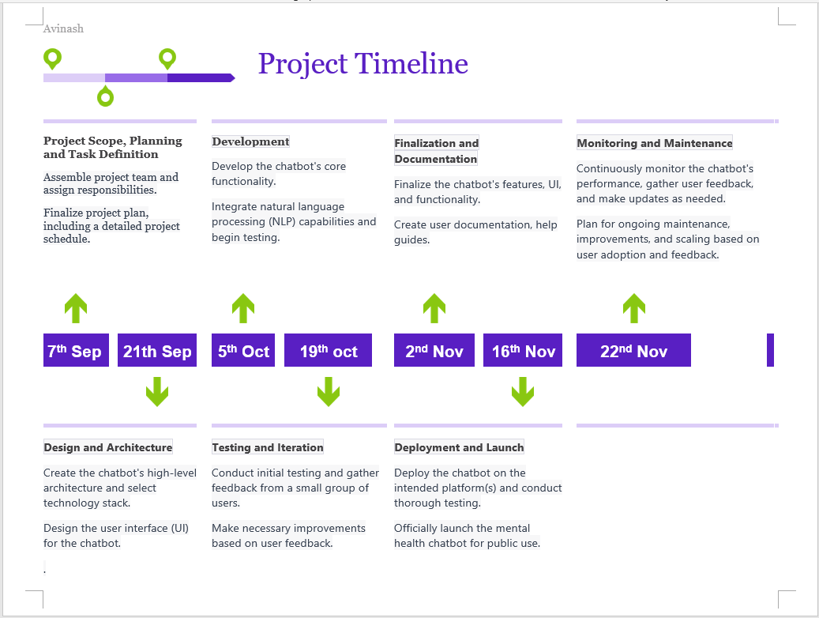

**Project Planning:**

Project planning for a chatbot involves laying out the foundational steps and considerations necessary to successfully develop and deploy a chatbot for a specific purpose. Here's a detailed project planning outline for creating a chatbot:

**1. Define the Project Objectives:**

-Clearly state the purpose and goals of the chatbot.

-Identify the target audience and their needs (e.g., mental health support for individuals experiencing anxiety or depression).

**2. Project Scope:**

-Determine the specific functionalities and features the chatbot will offer.

-Outline the limitations and constraints of the chatbot (e.g., it's not a substitute for professional therapy).

**3. Stakeholder Identification:**

-Identify key stakeholders, such as developers, designers, content creators, mental health professionals, and potential users.

-Assign roles and responsibilities to each stakeholder.

**4. Research and Data Collection:**

-Conduct research on existing mental health chatbots and competitor analysis.

-Collect relevant data, including mental health resources, articles, and potential conversational data.

**5. Technology Stack:**

-Decide on the technology stack for chatbot development (e.g., programming languages, frameworks, NLP libraries).

**6. User Interface (UI) Design:**

-Create wireframes and mockups for the chatbot's user interface.

-Ensure the UI is user-friendly and accessible.

**7. Conversation Design:**

-Develop conversation flows and dialogues.

-Define the chatbot's personality and tone, considering the sensitivity of the mental health context.

**8. Development:**

-Begin coding the chatbot using the chosen technology stack.

-Implement NLP and machine learning algorithms for natural conversations.

-Ensure data security and privacy measures are in place.

**9. Testing:**

-Perform rigorous testing to identify and fix bugs and errors.

-Test the chatbot's responses and interactions with real users or testers.

-Conduct stress testing to ensure it can handle a reasonable number of users simultaneously.

**10. User Training Data:**

- Gather training data to improve the chatbot's performance over time.

- Incorporate user feedback to enhance responses and understand user preferences.

**11. Integration:**

- Integrate the chatbot with relevant platforms and databases.

- Ensure it can seamlessly interact with users via websites, apps, or messaging platforms.

**12. User Documentation and Support:**

- Create user guides and FAQs to assist users in interacting with the chatbot.

- Establish a support system for users who may encounter issues or have questions.

**13. Ethical Considerations:**

- Ensure the chatbot adheres to ethical guidelines, respects user privacy, and provides accurate information.

- Establish protocols for handling crisis situations or users in distress.

**14. Deployment:**

- Deploy the chatbot on the chosen platforms (e.g., web, mobile apps, messaging apps).

- Monitor the deployment process for any issues.

**15. Marketing and Promotion:**

- Develop a marketing strategy to promote the chatbot's availability and benefits.

- Engage with potential users through various channels.

**16. Post-launch Monitoring and Maintenance:**

- Continuously monitor the chatbot's performance and user feedback. - Plan for regular updates, bug fixes, and improvements.

- Address any scalability issues that arise with increased user adoption.

**17. Evaluation:**

- Periodically assess the chatbot's effectiveness in achieving its goals.

- Gather metrics such as user engagement, user satisfaction, and the impact on mental health outcomes.

**18. Future Development:**

- Plan for future enhancements and expansions based on user feedback and changing needs.

**Data Preparation:**

**1. Introduction**

The data preparation phase is a critical component in the development of a chatbot for mental health support. In this section of the project report, we will outline the key steps and considerations involved in preparing the data necessary for the chatbot's training and operation.

**2. Data Collection**

Data collection is the initial step in data preparation, and it involves gathering the raw information needed to train and operate the mental health chatbot. The following sub-sections provide details on our data collection process:

**2.1. Data Sources**

We collected data from reputable sources, including academic research papers, mental health organizations, and trusted websites.

Data sources were chosen based on their credibility, relevance, and ethical considerations to ensure the information provided by the chatbot is accurate and trustworthy.

**2.2. Data Types**

We gathered various types of data, including textual content, user queries, and mental health resources.

Textual data includes articles, blog posts, and expert advice related to mental health topics.

User queries were obtained from public forums, social media, and anonymous user submissions.

**3. Data Preprocessing**

Data preprocessing is crucial to ensure the data is clean, structured, and suitable for machine learning algorithms. Here are the key steps we undertook:

**3.1. Text Cleaning**

We removed any irrelevant or redundant information from the collected textual data.

Text cleaning involved tasks such as removing HTML tags, special characters, and formatting inconsistencies.

**3.2. Text Tokenization**

We tokenized the cleaned text into individual words or phrases to facilitate further analysis.

Tokenization helps in breaking down text into meaningful units for NLP (Natural Language Processing) tasks.

**3.3. Stopword Removal**

Common stopwords (e.g., "and," "the," "is") were removed from the text to improve processing efficiency and focus on meaningful content.

**3.4. Lemmatization and Stemming**

We applied lemmatization and stemming techniques to reduce words to their root forms, enhancing the chatbot's understanding of text variations.

**4. Data Annotation**

To facilitate supervised learning, we annotated a subset of the collected data. Data annotation involved labeling user queries and responses to train the chatbot's understanding and generation capabilities.

**5. Data Privacy and Ethics**

Protecting user privacy and adhering to ethical guidelines were paramount throughout the data preparation process. We ensured that no personally identifiable information (PII) was included in the collected data, and user submissions were anonymized to maintain confidentiality.

**6. Conclusion**

In conclusion, the data preparation phase for the chatbot for mental health support project involved the systematic collection, cleaning, preprocessing, and annotation of data from diverse sources. This prepared dataset serves as the foundation for training the chatbot to provide accurate, reliable, and empathetic responses to users seeking mental health support. Our commitment to data quality, privacy, and ethical considerations underpins the project's success and the chatbot's ability to make a positive impact on individuals' mental well-being.

## Organization of Report

.

Chapter 1 : PROJECT SCOPE, PLANNING AND TASK

Chapter 2: LITERATURE REVIEW

Chapter 3 PRELIMINARY DESIGN

Chapter 4: DETAILED SYSTEM DESIGN/TECHNICAL DETAILS

Chapter 5: WORK ETHICS (By Supervisor)